**Task6 – Aliaksandr_Kudzelka**

**Ex1**

SELECT Table_NAME, OWNER

FROM SYS.ALL_TABLES

WHERE OWNER IN ('U_DW_REFERENCES', 'U_DW_EXT_REFERENCES', 'U_DW_COMMON')

UNION

SELECT VIEW_NAME, OWNER

FROM SYS.ALL_VIEWS

WHERE OWNER IN ('U_DW_REFERENCES', 'U_DW_EXT_REFERENCES', 'U_DW_COMMON')

ORDER BY 1;

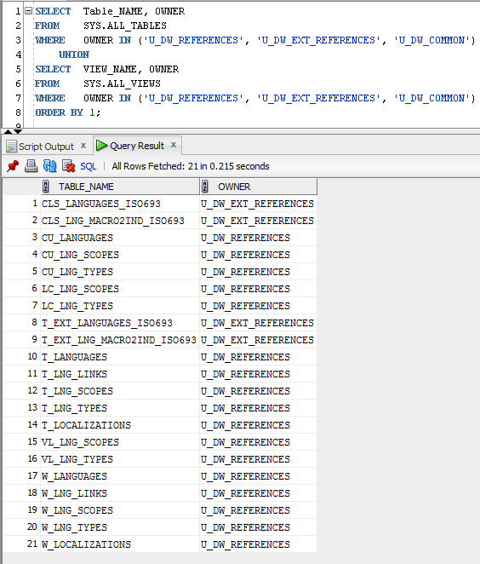

SELECT * FROM u_dw_references.t_localizations;

SELECT * FROM u_dw_references.cu_languages;

SELECT * FROM u_dw_references.w_lng_links;

SELECT * FROM u_dw_references.cu_lng_scopes;

SELECT * FROM u_dw_references.cu_lng_types;

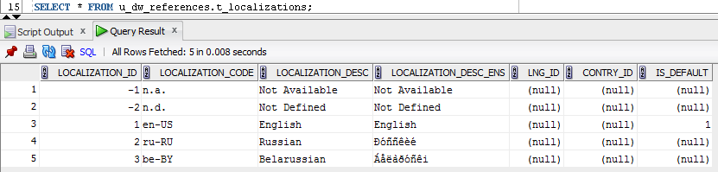

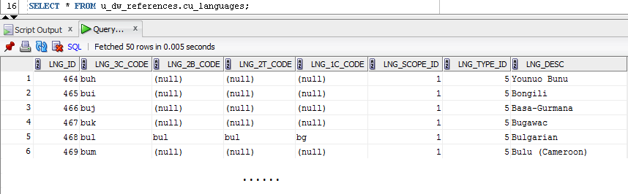

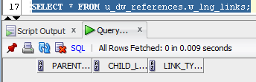

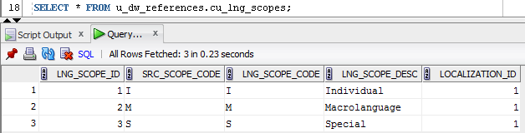

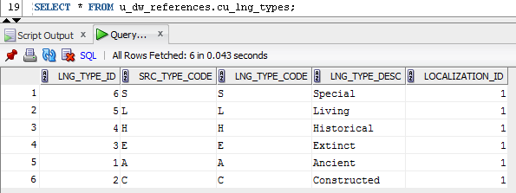

**Ex4 -** Creating Star Physical diagram and Logical diagram of solution.

* + Physical diagram

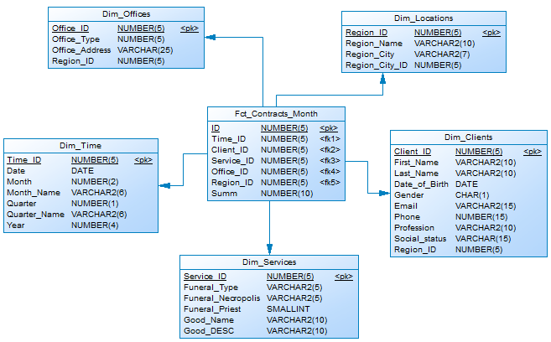

* + Logical diagram

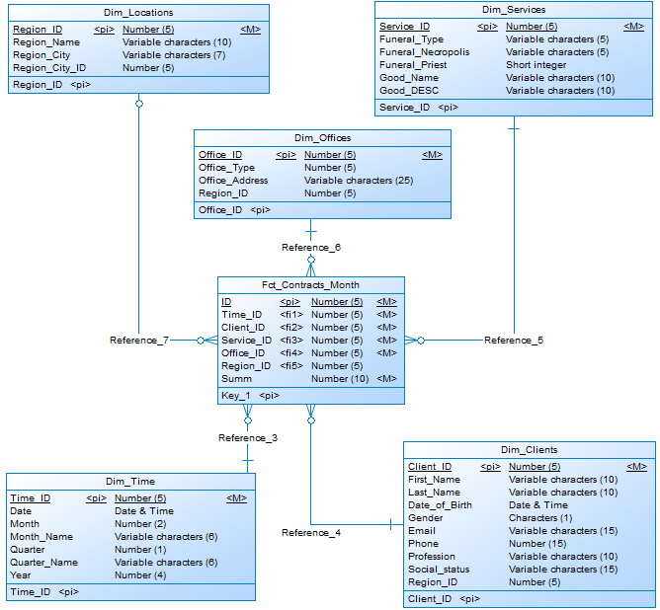

**Ex5 – Creating SnowFlake Physical diagram and Logical diagram of solution.**

* + Physical diagram

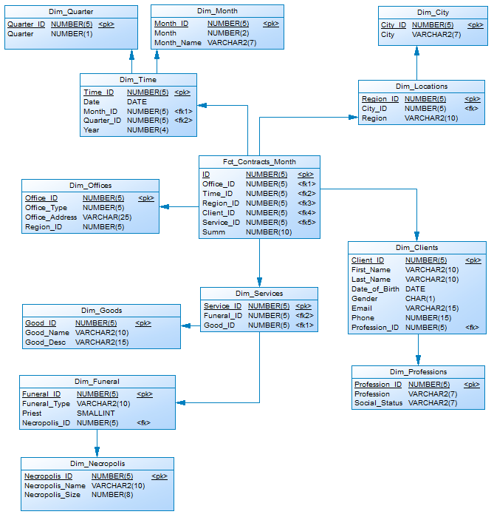

* + Logical diagram

